Japan to offer fast-track approval path for stem cell therapies
David Cyranoski
TOKYO — A retooling of Japan's drug authorization framework, on its way to becoming law, could produce the world's fastest approval process specifically designed for regenerative medicine. “I don't know of any other countries that have broken out with a separate and novel system” for cellular therapies, says University College London regenerative medicine expert Chris Mason, who recently met with Japanese policymakers to discuss the law.
Japan has recently been trying to shake its 'drug lag', a term used to describe its historically slow review process that sometimes translates into therapies reaching the market well after they have received the green light elsewhere. But the country is now ready to speed the translation of regenerative medicine to the bedside.
The move comes in response to the potential offered by its homegrown induced pluripotent stem (iPS) cell technology, which netted Shinya Yamanaka, of the University of Kyoto, last year's Nobel Prize in Medicine or Physiology. The government already flooded the field with more than 20 billion yen ($206 million) in a supplementary budget announced earlier this year, and it's expected to allocate another 90 billion yen into the sector over the coming decade.
Under the Pharmaceutical Affairs Law as it currently stands, regenerative therapies, like small-molecule drugs, must undergo three phases of costly and cumbersome clinical trials to get approval by Japan's Pharmaceutical and Medical Devices Agency.
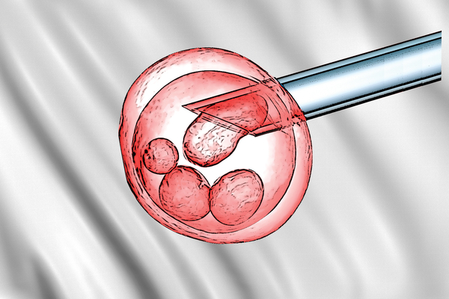
Matt Hansen
Land of the rising stem cell: Regenerative therapies gain accelerated path to the Japanese market.
The proposed amendments to the pharmaceutical law will create a new, separate approval channel for regenerative medicine. Rather than using phased clinical trials, companies will have to demonstrate efficacy in pilot studies of as few as ten patients in one study, if the change is dramatic enough, or a few hundred when improvement is more marginal. According to Toshio Miyata, deputy director of the Evaluation and Licensing Division at the Pharmaceutical and Food Safety Bureau in Tokyo, if efficacy can be “surmised,” the treatment will be approved for marketing. At that stage, the treatment could be approved for commercial use and, crucially for such expensive treatments, for national insurance coverage.

Phased out
With the bar for regenerative therapies dramatically lowered by requiring only limited safety and efficacy data—and essentially doing away with the need for high-powered phase 3 trials—the amendments' architects say it will be possible to get a stem cell treatment to the market in just three years, rather than the typical six or more. The law should also give local producers of regenerative medicine an edge even over those selling stem cell therapies in South Korea, where an accelerated system has helped companies get more stem cell treatments on the market than any other country (see Nat. Med. 18, 329, 2012). “It's bold,” says Yoshihide Esaki, director of Bio-Industry Division, a bureau of the Ministry of Economy, Trade and Industry based in Tokyo, which promoted legislation calling for the update.
Following approval, there will be a post-market surveillance period of five to seven years, after which the treatment will be evaluated again for safety and efficacy. Every patient must be entered in a registry during that period, says Miyata. If the therapies prove inefficacious or unsafe, approval can be withdrawn.
Doug Sipp worries whether post-market surveillance will turn up relevant data. Sipp, who studies regulatory issues related to stem cells at the RIKEN Center for Developmental Biology in Kobe, Japan, says that making people who receive the therapies during this period cough up even the 30% co-pay generally required under Japan's national insurance plan “will essentially be asking patients to pay for the privilege of serving as the subjects of medical experiments.” And since the patients are paying, the studies cannot be randomized or blinded. Paying patients are also more likely to experience placebo effects, Sipp warns.
“There's also the opportunity costs to patients,” who might be able to find better therapies elsewhere, adds Mason. “We have to make sure these therapies are safe and effective. Otherwise these regulatory routes are going to be closed.”
Despite these concerns, passage of the pre-vetted law is almost a given. Esaki says there's a 50% chance the Japanese parliament will pass the law during the current session, ending in June. If so, it would go into effect next April. If not, scientists might have to wait until November 2014 or as late as April 2015.

